2019 BST BARGAINING SUGGESTIONS
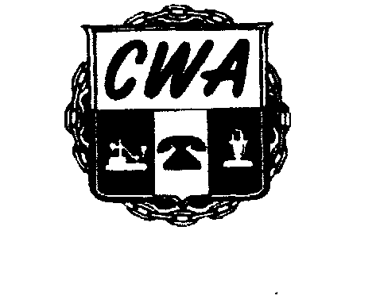
For CWA Local 3204 Union Members
UNION MEMBERS: Using one form per suggestion, please submit your 2019 Bargaining Suggestion by Friday, March 1, 2019. Please give specific examples to make your point.

Completed forms can be faxed to Union Hall at 404-688-6236 or emailed to suggestions@cwa3204.org (Please use this format in the email.)

CONTRACT ARTICLE: _____________________ PAGE NUMBER: _____________________________

SUGGESTION: ____________________________________________________________________________

_______________________________________________________________________________________

REASON: ________________________________________________________________________________

_______________________________________________________________________________________

_______________________________________________________________________________________

SPECIFICEXAMPLE: ________________________________________________________________________

_______________________________________________________________________________________

Please provide the information below. You may have to be contacted for clarification. Please print.
Submitted by: ____________________________________________Title:_____________________________________
Work Location/Department: _________________________________________________________________________
Best Contact Number: _____________________________PersonalEmail:_____________________________________

CWA LOCAL 3204 / 279 LOGAN STREET / ATLANTA, GEORGIA 30312 / 404-688-1256

